

The Eagle

## A newsletter published by The Literacy Center

/

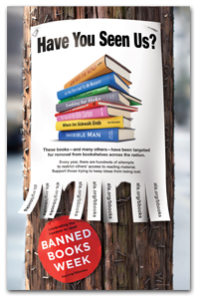

Mrs. Nguyen– Librarian

Fall 2017

Volume 1, Issue 1

# Rewrite History....

Social Media Consultant, YA Book Blogger

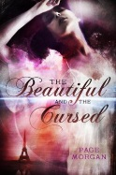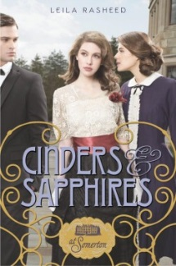 

Upcoming Events:

**Banned Books Week 2017:**

Sept. 24 - Sept. 30

**Teen Read Week:**

October 8th – 14th.

**This month’s PD:**

One Note and Classroom Notebook

**This months TECH TOOLS:**

Plickers

Zipgrade

❸ **Historical Fantasy**

*Grave Mercy* by Robin LaFevers -- This book is set in an altered medieval England and places the characters beside the gloomy and ancient convent of St. Mortain. Definitely an atmospheric read.

❹ **Set in Paris**

*The Beautiful and the Cursed* by Page Morgan -- This is a gorgeous tale of gargoyles and ancient vows, all set in the city of lights. I didn't realize how many YA historical fiction books were set in Paris, but I'm thankful!

❺ **New**

*Prisoner of Night and Fog* by Anne Blankman -- In 1930s Munich, Gretchen has a dangerous relative. And his name is Adolf. If that doesn't hook you already, I don't know what will.

Bored in history class? Get the other side of the story with these ***must-read*** popular YA (Young Adult) books.

❶ **Aristocratic England**

*Cinders and Sapphires* by Leila Rasheed -- I

adored this YA version of Downton Abbey (a

tagline for the book is "At Somerton"). It's

probably the closest YA fans will get to reliving

a Downton Abbey type time and period setting.

❷ **The 20s**

*The Diviners* by Libba Bray -- There is so much sass in this New York City set 20s book. The era-specific sayings and the spunk of the main character Evie will make you think you've accidentally slipped into a speakeasy.

Awesome Highlighter: Awesome Highlighter lets you highlight text on web pages and then gives you a small link to the highlighted page.

BBC’s Bitesize Games: From the BBC, this site provides a number of interactive game options including rhyming words, phonics, ABC order, pronouns, punctuation, and more. Note: audio has British accent. http://www.bbc.co.uk/schools/ks1bitesize/literacy/

BBC’s Bitesize English: The next level of English activities includes reading, writing, spelling & grammar. Each activity includes an interactive learning game, a ―bitesize‖ lesson, and a quiz. http://www.bbc.co.uk/schools/ks2bitesize/english/

BBC’s Words and Pictures: For those who have completed Bitesize Games, here are activities for writing, more phonics, sight words, and more. http://www.bbc.co.uk/schools/wordsandpictures/index.shtml

Dogo News: Kids‘ news articles & current events. ―Fodder for young minds‖ http://www.dogonews.com/

## **This months resources:**

**Follow us on The Literacy Center**

**Website:**

**http://snguyen487.wixsite.com/theliteracycenter**

Out of 307 challenges as reported by the Office for Intellectual Freedom:

1. ***This One Summer*** written by Mariko Tamaki and illustrated by Jillian Tamaki.

This young adult graphic novel, winner of both a Printz and a Caldecott Honor Award, was restricted, relocated, and banned because it includes LGBT characters, drug use, and profanity.

1. ***Drama*** written and illustrated by Raina Telgemeier.

Parents, librarians, and administrators banned this Stonewall Honor Award-winning graphic novel for young adults because it includes LGBT characters, and was considered to have an offensive political viewpoint.

1. ***George*** written by Alex Gino

Despite winning a Stonewall Award and a Lambda Literary Award, administrators removed this children’s novel because it includes a transgender child.

1. ***I Am Jazz*** written by Jessica Herthel and Jazz Jennings, and illustrated by Shelagh McNicholas

This children’s picture book memoir was challenged and removed because it portrays a transgender child and because of language, and offensive viewpoints.

1. ***Two Boys Kissing*** written by David Levithan

Included on the National Book Award longlist and designated a Stonewall Honor Book, this young adult novel was challenged because its cover has an image of two boys kissing, and it was considered to include LGBT content.

1. ***Looking for Alaska*** written by John Green

This 2006 Printz Award winner is a young adult novel that was challenged and restricted for a explicit scene.

1. ***Make Something Up: Stories You Can’t Unread*** written by Chuck Palahniuk

This collection of adult short stories, which received positive reviews from Newsweek and the New York Times, was challenged for profanity, and being “disgusting and all around offensive.”

1. ***Little Bill*** (series) written by Bill Cosby and illustrated by Varnette P. Honeywood

This children’s book series was challenged because of criminal allegations against the author.

1. ***Eleanor & Park*** written by Rainbow Rowell

One of seven New York Times Notable Children’s Books and a Printz Honor recipient, this young adult novel was challenged for offensive language.

Techie Tom’s Tech Tip:

Still figuring out Microsoft Office 365?

Mrs. Nguyen is always available for help.

# Top 9 - 2016 ***challenged* books**

# 