

The Eagle

## A newsletter published by The Literacy Center

/

Mrs. Nguyen– Librarian

Fall 2017

Volume 1, Issue 2

# NEED SOME DIVERSITY IN YOUR LIFE?....

Social Media Consultant, YA Book Blogger

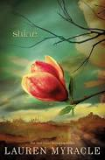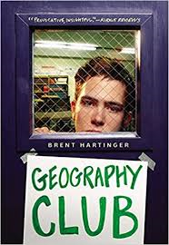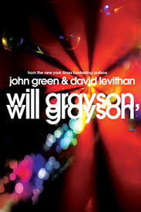 

Upcoming Events:

**This month’s PD:**

Edpuzzle

**This months TECH TOOLS:**

Britannica Launch Packs

Canvas

❸ **Fantasy**

*Ash* by Malinda Lo -- In the wake of her father's death, Ash is left at the mercy of her cruel stepmother. Consumed with grief, her only joy comes by the light of the dying hearth fire, rereading the fairy tales her mother once told her. In her dreams, someday the fairies will steal her away, as they are said to do. When she meets the dark and dangerous fairy Sidhean, she believes that her wish may be granted.

❹ **Young Adult Mystery**

*Shine by Lauren Myracle follows a teenage girl who is investigating the hate crime involving her best friend who is nearly beaten to death. Takes place in a small town North Carolina. Winner for best YA novel ALA Readers’ Choice.*

Looking for something a little bit more modern. Check out these new books in the library.

❶ **Realistic Fiction**

*Will Grayson, Will Grayson* by John Green

It's not that far from Evanston to Naperville, but Chicago suburbanites Will Grayson and Will Grayson might as well live on different planets. When fate delivers them both to the same surprising crossroads, the Will Graysons find their lives overlapping and hurtling in new and unexpected directions.

❷ **Realistic Fiction**

*Geography Club by* Russel Middlebrook – Life for teenagers is tough, especially in high school. Kevin pretends to be who he is not just to fit in. Can he keep his secret safe? You have to read it to find out.

Social Studies and ELA:

Are you looking for some new resources to use in class? Maybe you want a way for students to have access to only resources you select for them. Well I have the site for you.

**Britannica Launch Packs.**

Launch Packs Social Studies combines up-to-date, curriculum-aligned content sets with tools that make it easier for teachers to differentiate instruction and for students to understand core K-12 Social Studies topics.

Visit: <https://packs.eb.com/social-studies>

SIGN UP TODAY

School code: AB80

## **This months resources:**

**Britannica Launch Packs:**

1. **A build in lesson plan builder.**
2. **Differentiate reading by grade level.**
3. **Article annotate tool.**
4. **Ability to switch Lexile levels.**
5. **Page tools to cite, translate, and ‘  
   quick click dictionary.**
6. **Has ability to read text to student.**
7. **Student and teachers can make accounts.**

**Follow us on The Literacy Center**

**Website:**

**http://snguyen487.wixsite.com/theliteracycenter**

Techie Tom’s Tech Tip:

Still figuring out EDPUZZLE?

Mrs. Nguyen is always available for help.